## Objective: Choose the correct conditional (ternary) operator to alert "Too young" if age is less than 18, otherwise alert "Old enough" using JavaScript.

## Code:-

# HTML:-

# <!DOCTYPE html>

# <html lang="en">

# <head>

# <meta charset="UTF-8">

# <meta name="viewport" content="width=device-width, initial-scale=1.0">

# <title>Age Authentication</title>

# </head>

# <body>

# <label for="age" style="font-weight:bold;">Enter Your Age :-</label>

# <input type="number" name="age" id="age">

# <input type="button" value="Check" onclick="Check()">

# <script>

# function Check() {

# var Age = document.getElementById("age").value;

# var warning = Age > 18 ? "Old enough" : Age < 0 ? "Age Should Be Positive" : "Too young";

# alert(warning);

# }

# </script>

# </body>

# </html>

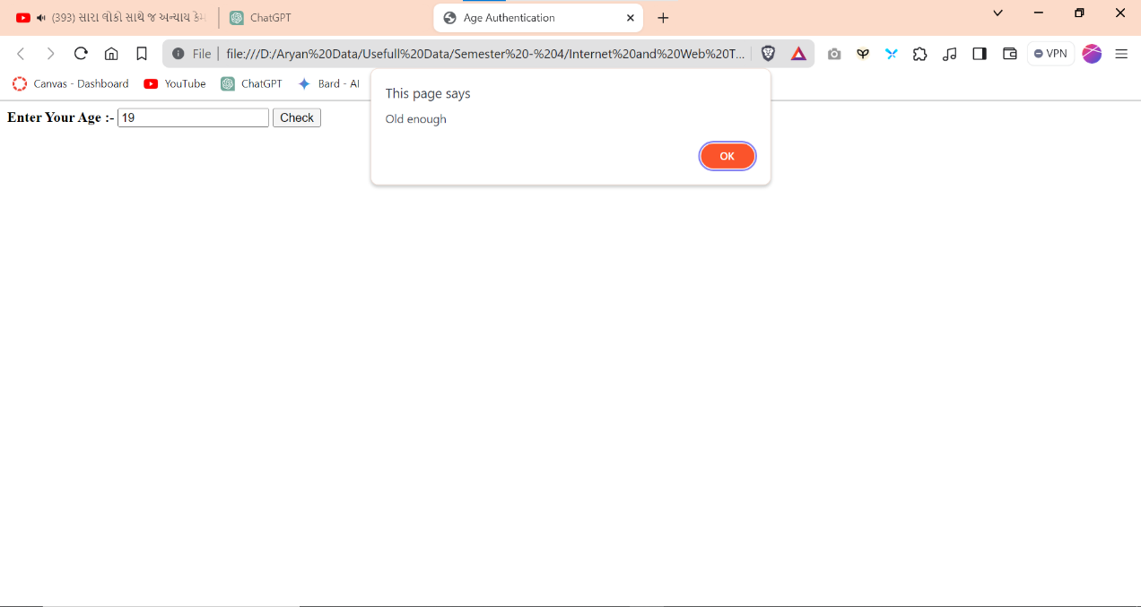**Output :-**